For each SDI source system connection created by basis grant below access for system user id’s _SYS_REPO and SAPABAP1 in H9D/Q/P to allow creation of virtual tables

Grant CREATE VIRTUAL TABLE on remote source "E6D_DPA" to "_SYS_REPO" ;  
Grant CREATE VIRTUAL TABLE on remote source "E6D_DPA" to "SAPABAP1" ;

SAP ABAP ADAPTER on HANA server

1. HANA ETL can be done using flowgraph on virtual tables from ABAP application (E6P & E8P)

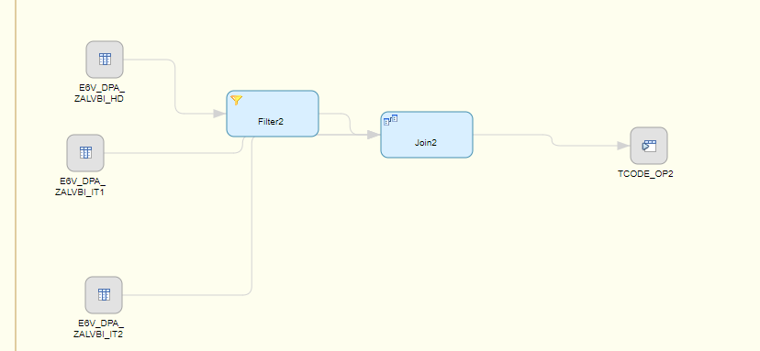

HANA SQL functions available for use

Filter node using HANA SQL functions

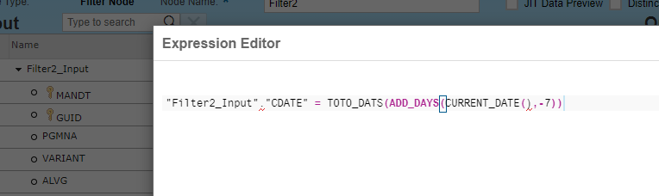

Mapping/Transform using HANA SQL functions

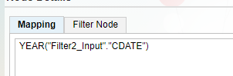

Joins

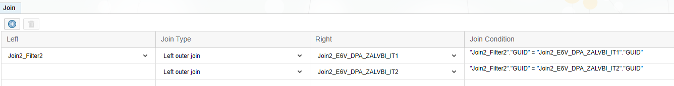

Flowgraph generates/creates a stored proc in the specified schema

DB syntax to execute flowgraph

call "MDQ_DASHBOARD"."developers.pamudurs.temp::CopyOfTCODE_OUPTUT_SP"();

1. Replication task – Can be used to replicate multiple tables data to HANA

Using ABAP connector data can be replicated to HANA tables. Supports only Initial load

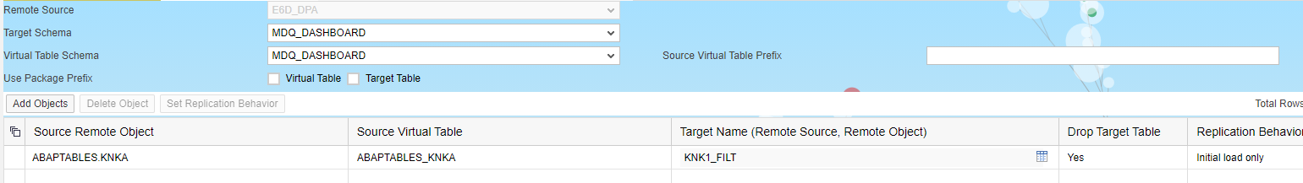

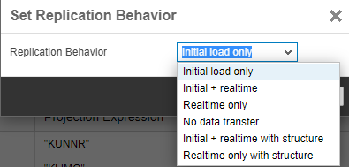

Truncate and Initial replication can be done each time/Initial replication first time and apply filters to update the tables

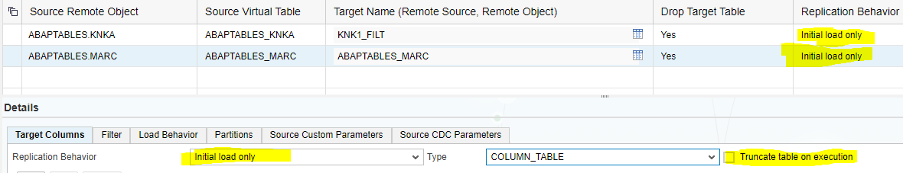

Replication task generates/creates a stored proc in the specified schema

DB syntax to execute Replication task

call "MDQ_DASHBOARD"."developers.pamudurs.temp::TEST_REPTASK.START_REPLICATION"

1. Scheduling and monitoring the flowgraphs and replication tasks can be done through Data Provisioning Agent and Data Provisioning Task monitors.

Task monitor Link from Dev

<https://saph9dv.owenscorning.com:4335/sap/hana/im/dp/monitor/?view=IMDesignTimeObjectMonitor&package=BW_Test&objectName=FG_TEST2&objectType=hdbflowgraph>

HANA Table to check the task executions. This can be leveraged to monitor the status

**select** * **from** "_SYS_TASK"."TASK_EXECUTIONS"

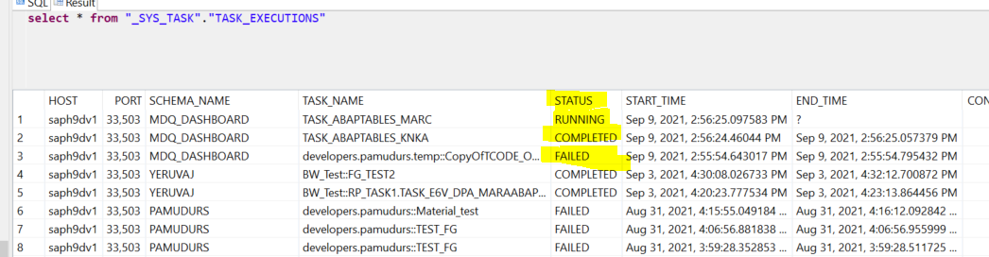

BW ETL with SDI connection

MARC all fields transferred

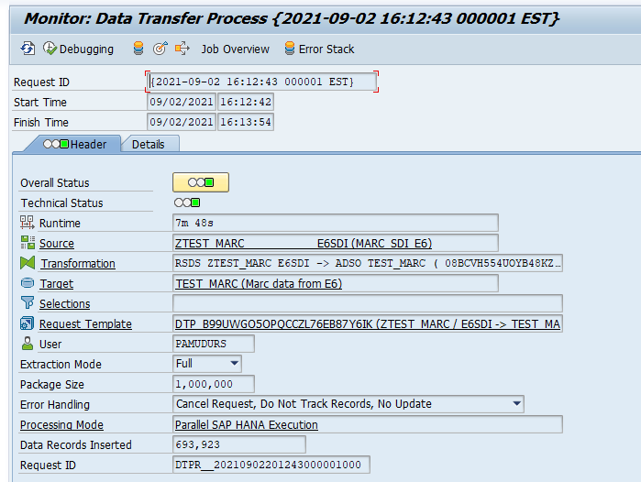

MARC few fields transferred

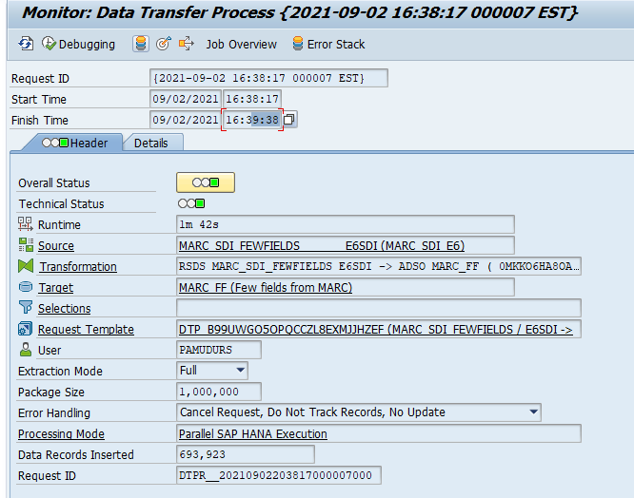

SAP Help and Blogs on SDI and HANA ETL

<https://blogs.sap.com/2019/03/25/extraction-from-sap-s4hana-and-other-abap-sources-into-hana-sql-dw-with-smart-data-integration/>

<https://help.sap.com/viewer/7952ef28a6914997abc01745fef1b607/2.0_SPS04/en-US/6ed502701abd4d1ca94d463d7dc6e99f.html>

<https://help.sap.com/viewer/71c4a6e6b4dc4a5ab3e17bb1d7e98104/2.0_SPS05/en-US/cc832d5253c54ff4ae86b02e56e47cf8.html>

Schedule flow graphs

<https://help.sap.com/viewer/d60a5abb34d246cdb4ab7a4f6b9e3c93/2.0_SPS05/en-US/701be86d4ad3470485ee4ecb25258ba2.html>

<https://blogs.sap.com/2016/01/11/hana-smart-data-integration-one-stop-solution-data-handling/>

<https://blogs.sap.com/2018/06/15/hana-sdi-is-super-set-of-all-if-and-only-if-hana-is-the-main-data-target./>